# Web technologies

Semiguk Petr(S1030456)

# Pages structure

| Header |
| --- |
| Navigation panel |
| Page information |
| Footer |

# Screenshots

All pages contain a navigation panel.Navigation panel links all pages between each other.



# 

All pages also contain footer. Footer contains copyright sign and links for zoo social media pages.



## 

## Homepage

Homepage contains introducing words for our guests, slider which shows animal residents, table with activities.

slider

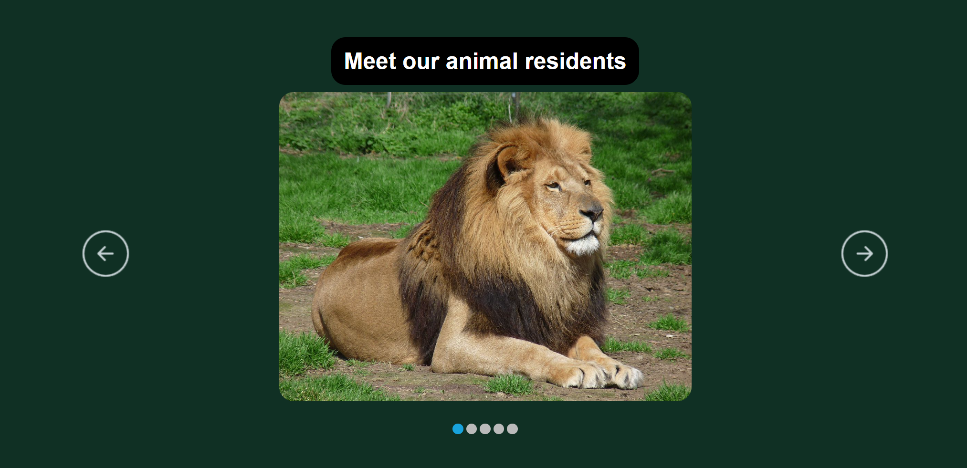

table

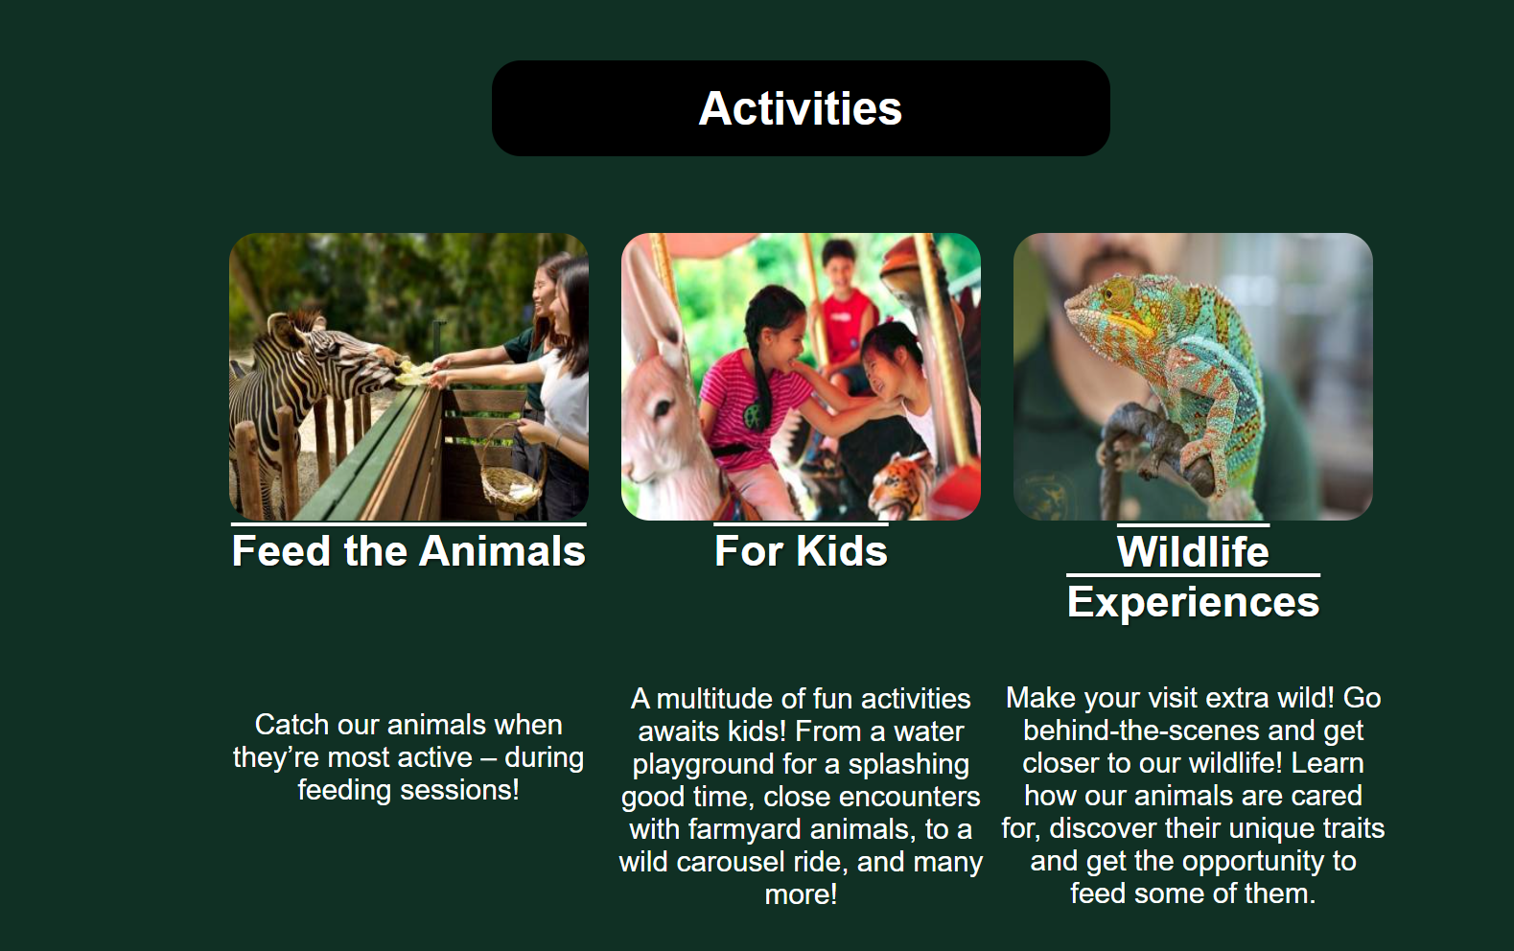

## 

## About us

page “About us” Contains information about park and also have information about other our parks.

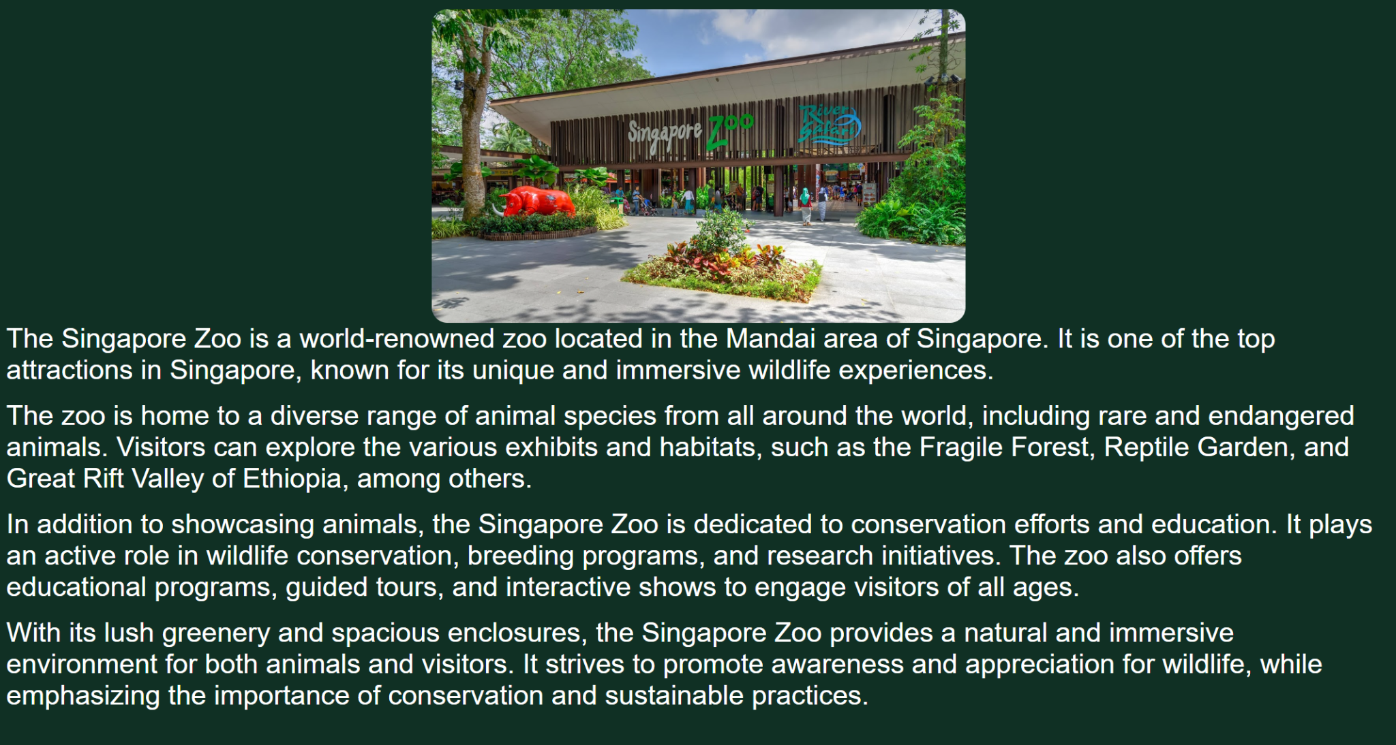

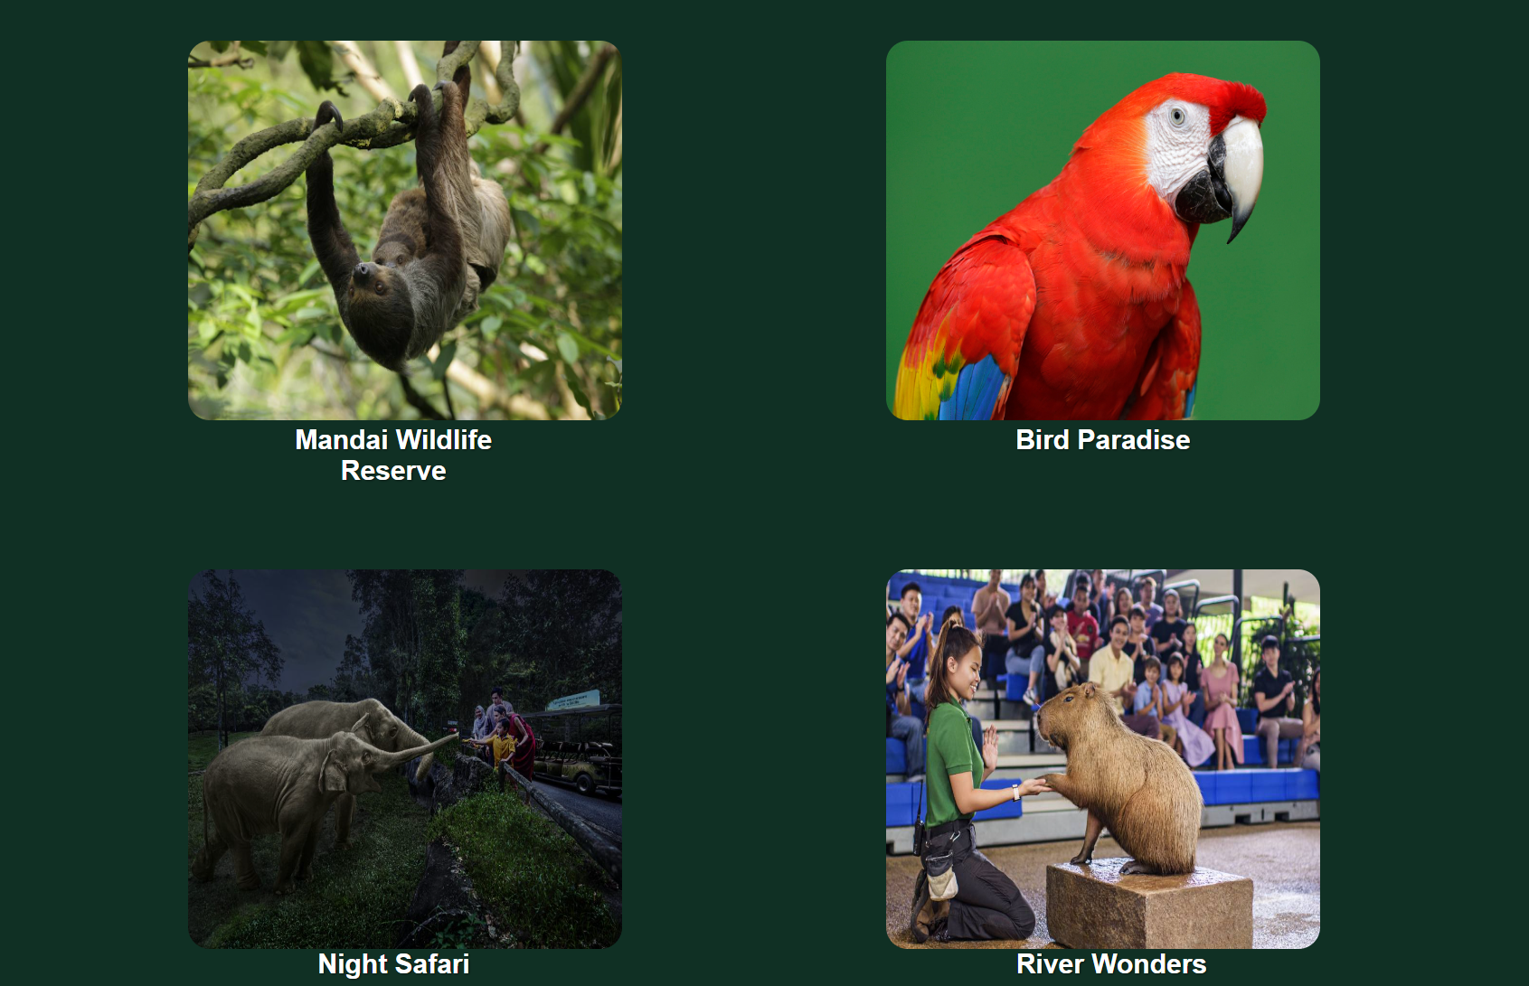

## Tickets

Page “tickets” contains a convenient form for buying tickets.

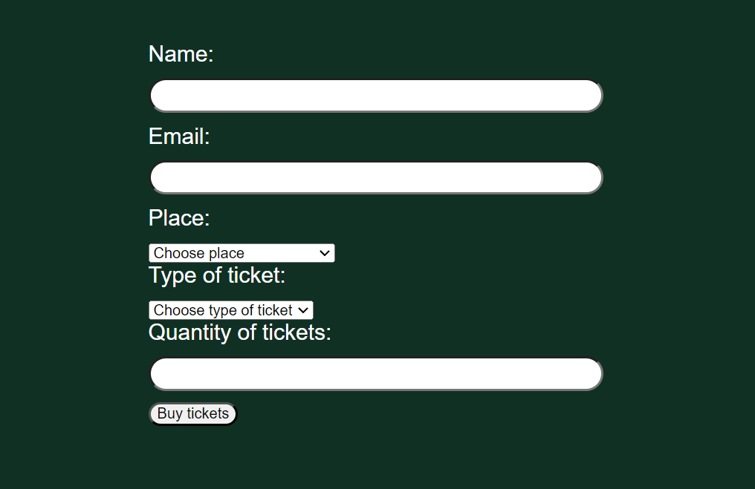

## Events

Page “Events” contains tables with all our future events and short information about them.

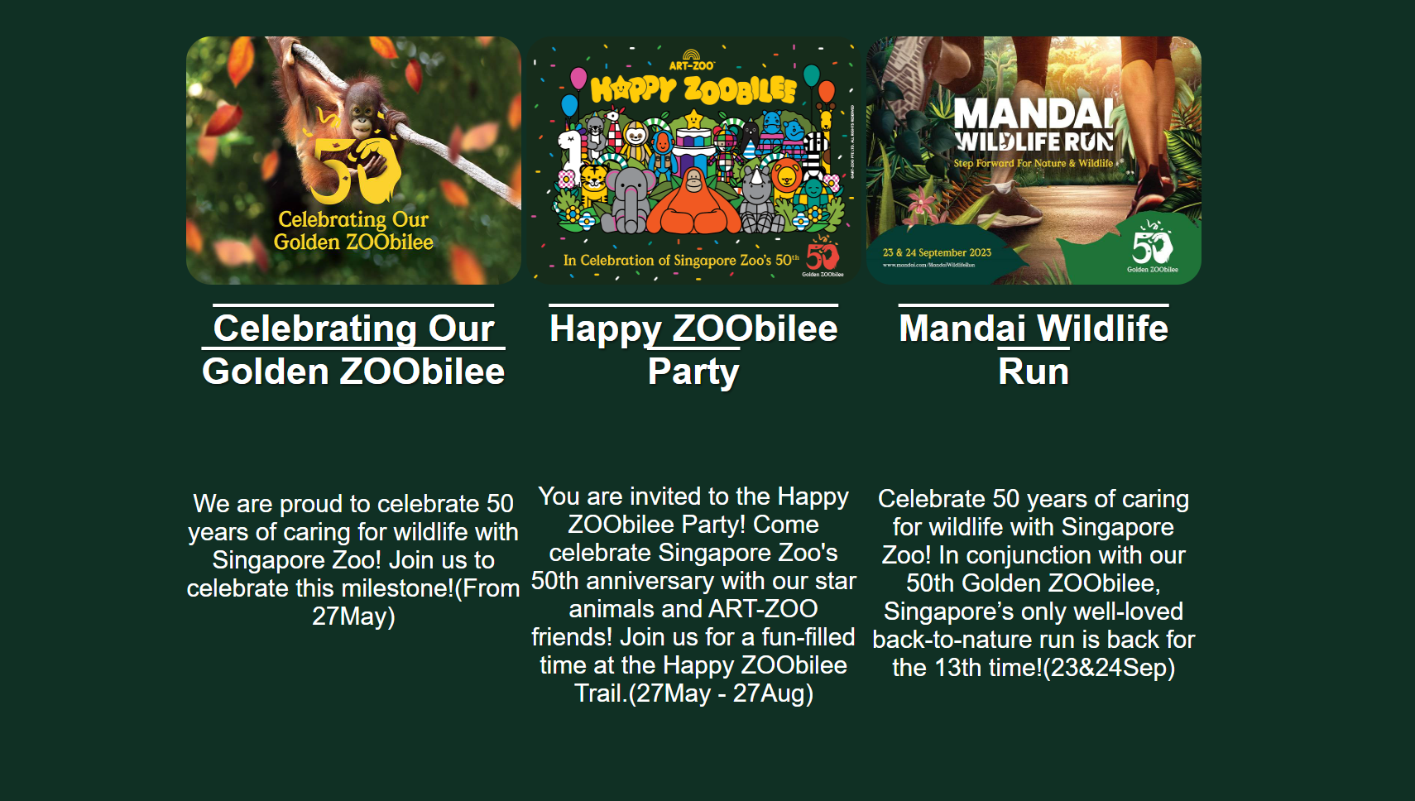

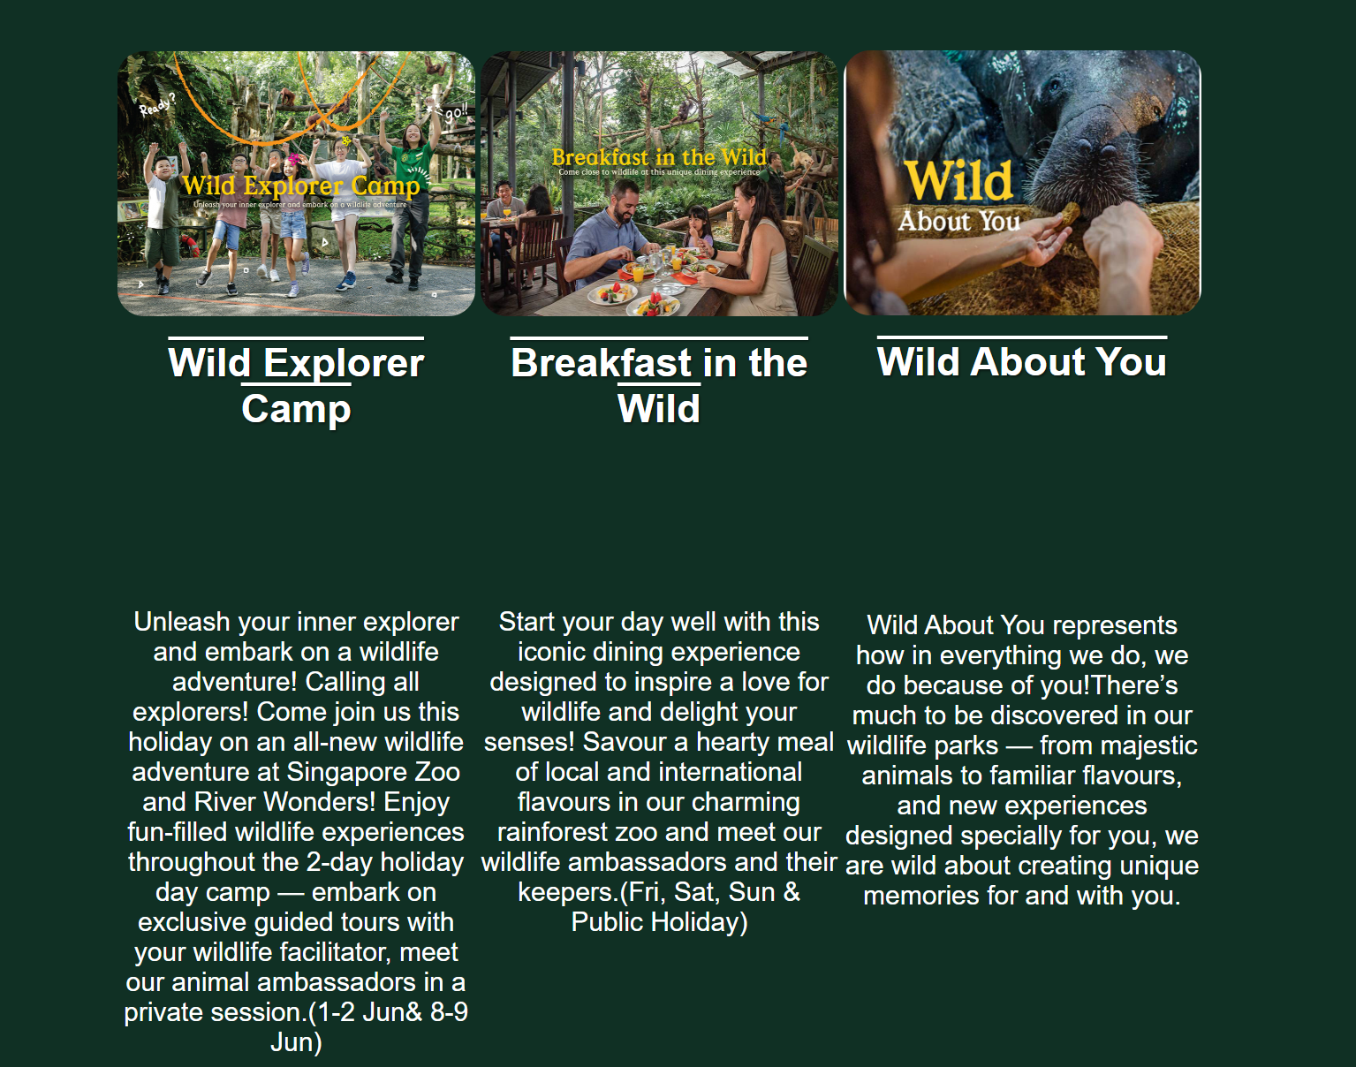

## Contact Us

Page “Contact Us” contains a convenient form, where you can leave your contacts and describe your question to us.

